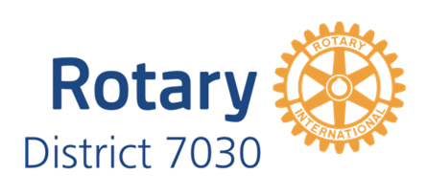

District 7030 EnviroClub Awards

Application Form – Gold Award
A Gold Award is the third of three levels of recognition of your club’s environmental achievements. The District 7030 Environmental Sustainability Committee will review your application on the basis of criteria at the appropriate level for the Award. The Committee will then make a recommendation to the District Governor who will make the final decision as to whether your club receives this level of Award. Refer to the District website for further details about requirements and assessment criteria. Please complete all sections below.
Rotary Club Name

Rotary Year

Name of Club Environment Officer
Club ES Committee formed | - YES  - No
Holds current Silver Award | - YES  - No
Signature of Club Environment Officer
Name and signature of Club President
Date

Summarise your club’s application for a SILVER Award below
- Additional environmental activities, projects and events to those reported in the application for the BRONZE and/or SILVER Awards

- Demonstration that the projects and events described in the BRONZE and/or SILVER Awards application have been significantly improved

- Evidence of communicating the environmental initiatives reported in the application for the BRONZE Awards (e.g. in the club/District newsletters and/or the media/significant social media)

For official use only
Date received

Date considered by District Environmental Sustainability Committee
Committee’s observations and recommendations
Date approved by District Governor
Initials of District Governor
Date Award presented to club

